Setting Up JUnit

### ****Create a Java Project****

At first open extensions and install Extension pack for java and debugger.

Then click Testing and select Enable Java tests.

Use the built-in Java tools in VS Code:

Press Ctrl+Shift+P → Select Java: Create Java Project

Choose **No Build Tools** (or use Maven/Gradle if preferred)

Select a folder to create the project

Give the project a name

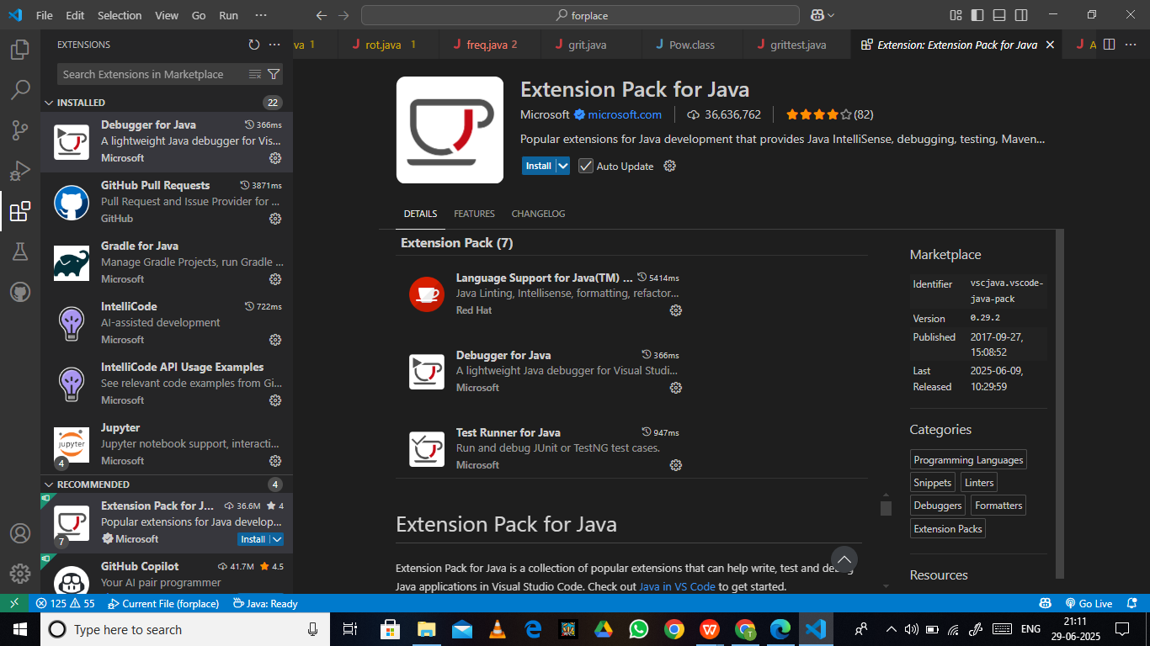

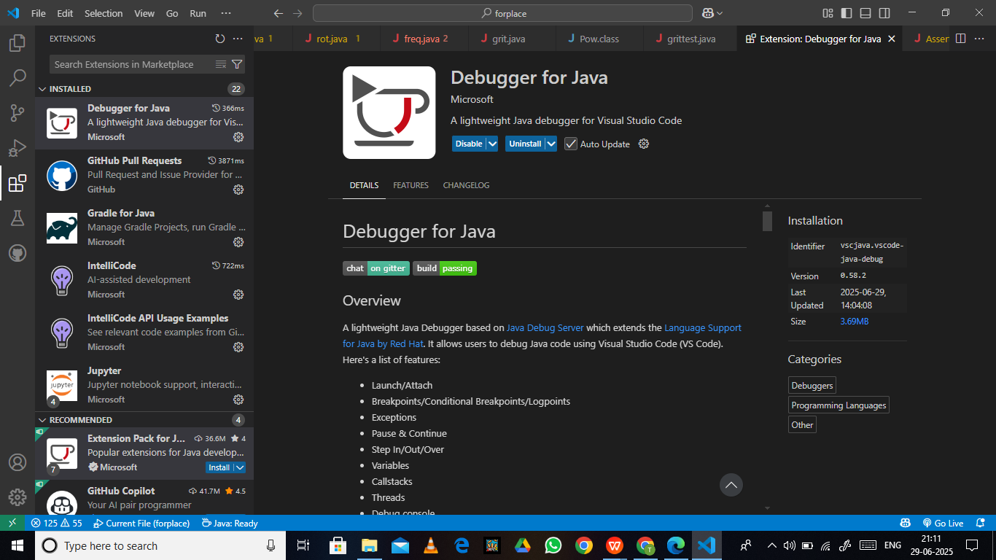

Then select Junit and install Jar files.

Then install all the required dependencies.

Simple program for implement Unit testing.

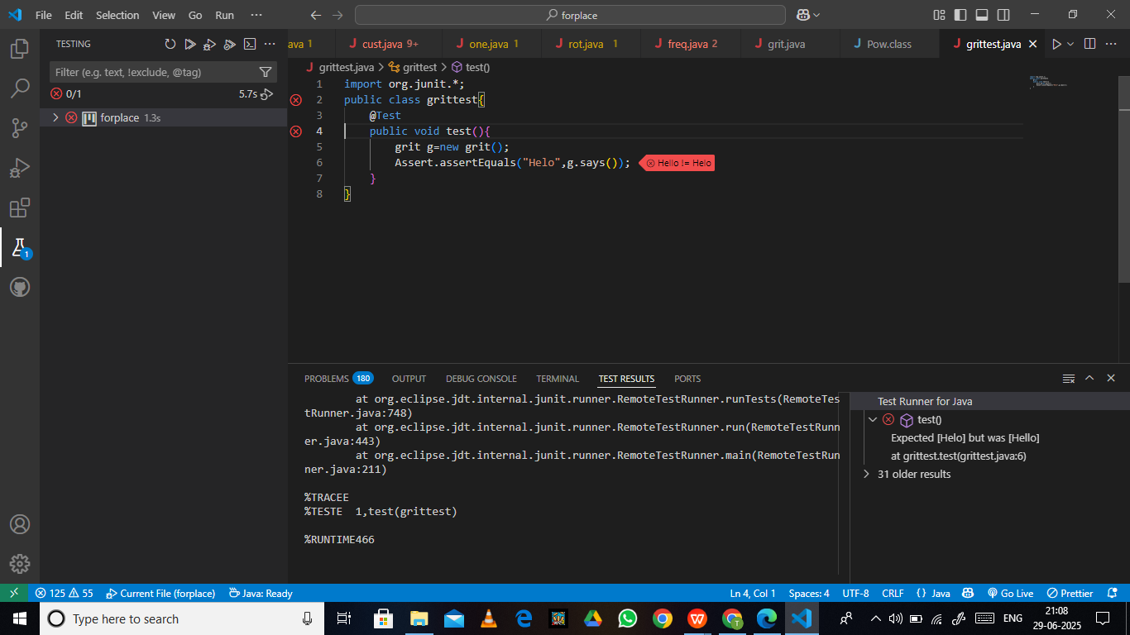

This is the failed case while testing.

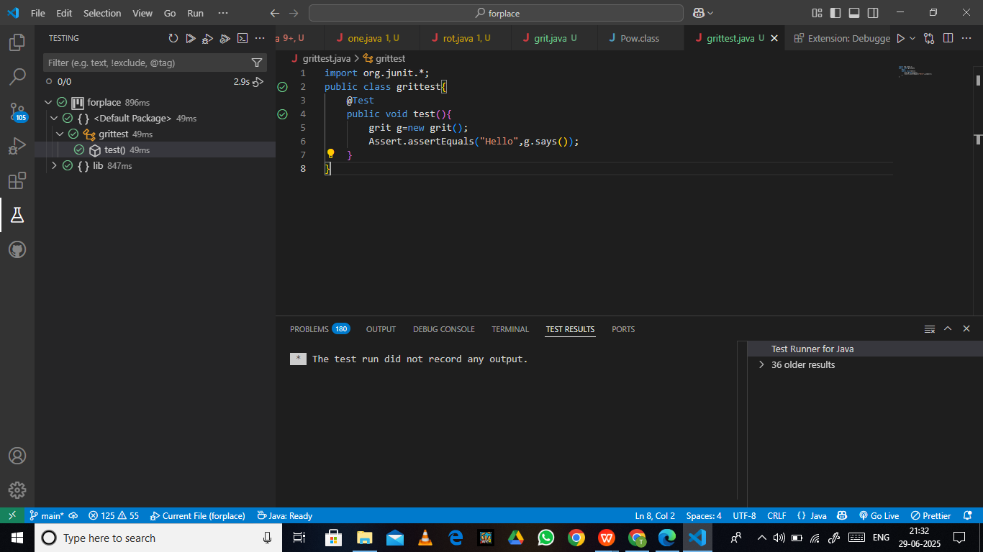

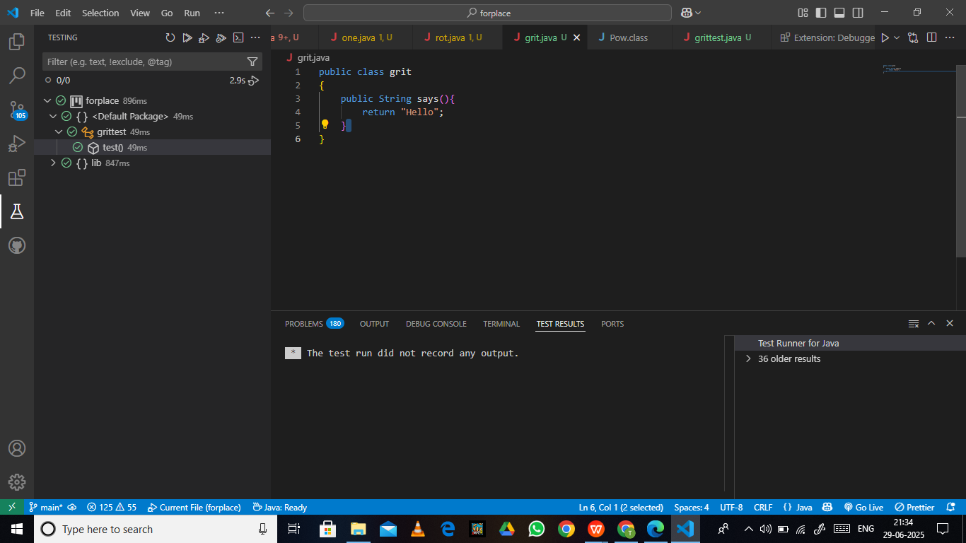

This is the Successful testing where the program returns hello.

Assertions in JUnit

Simple program to implement all assert methods.

